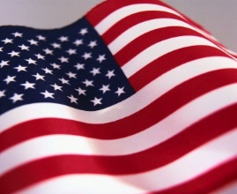　　　 　　　　　　　　　　 **Today is Independence Day.**

**Happy July 4th!**おめでとうアメリカ！

I am going to celebrate this day with my family and friends.

I would like to do something special today.

Usually I didn’t turn on TV early in the morning but I wanted to know what’s going on outside, because I am still new here after moved from Japan at the end of December 2010. Last year I didn’t know almost anything going on but now I really feel a tiny, tiny, tiny part of America!

 I bought some flowers for celebration. I wondered how to

Add blue to red and white

Hard to find blue flower around me so a vase or a ribbon

Flowers at home. This is solution!

My blue Ford , White lilies, Red Roses

I would like to celebrate this day with Teddy Bears. One from America, One from Japan.

One from Thailand we traveled to. For Cerebration I should have bought more flowers!

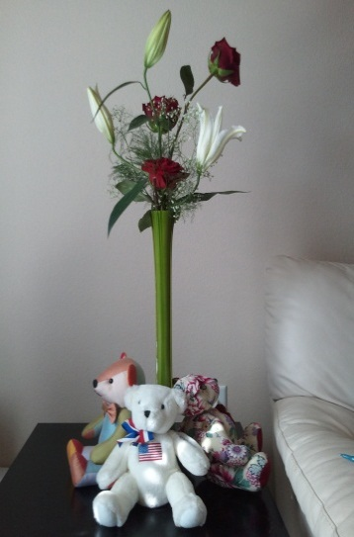

きょうは、やとこのをしたいと。

2012のににばかりです。はもわからなかったのですが、はもににけれどアメリカの一とています.

アメリカのの、、、をシンプルに花を生けました。

がないので。のがなので、、で。

このは　、、にったタイのもの。

でもやっぱりおはもっとたくさんのがったみたいです。

